Question 1 Output

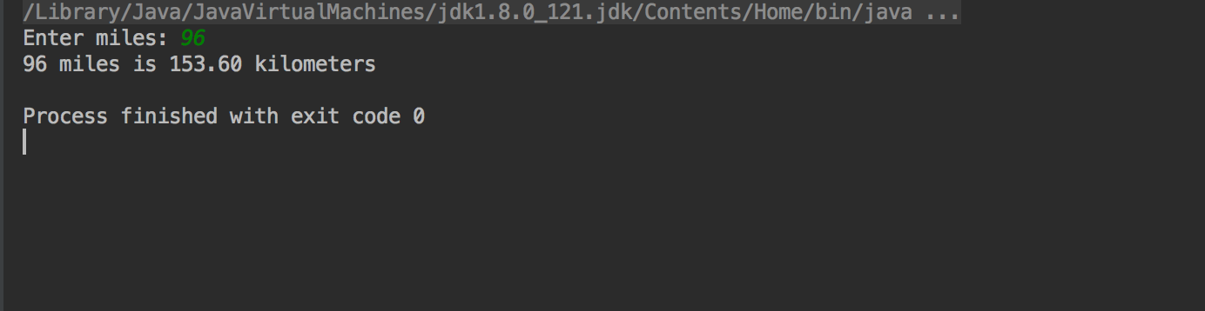

Question 2 Output

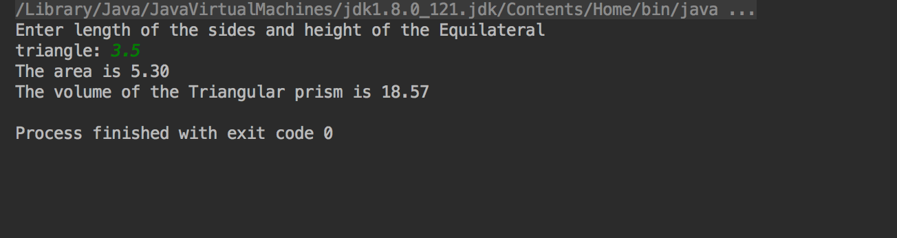

Question 3 Output

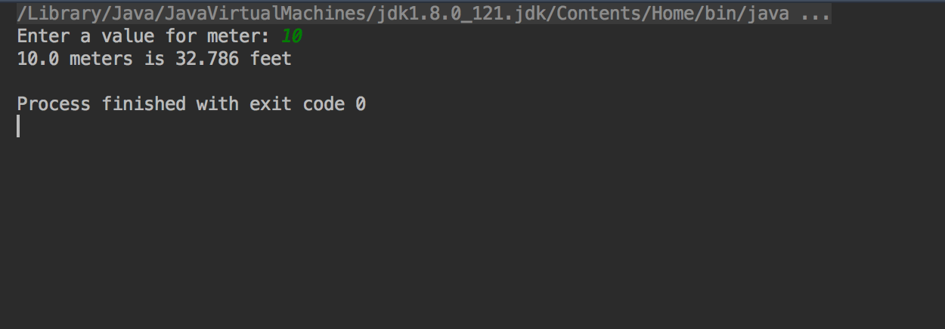

Question 4 Output

